StudyMate AI: Neural Study Assistant

A Minor Project-II Report
Submitted By:
(23BT04D165) Umar Ansari
(23BT04D170) Nij Dave
(23BT04D189) Jay Patil
(23BT04D191) Dhruvin Rajpura

In partial fulfilment of the requirement for the award of
the degree
of

Bachelor of Technology In
Semester VII-Computer Science and Engineering (Data Science, AI & ML)
At
Department of Computer Science and Engineering
School of Technology

GSFC University,
Vigyan Bhavan, P. O. Fertilizer Nagar,
Vadodara - 391750, Gujarat, India
May 2025

CERTIFICATE

This is to certify that the report submitted along with the project entitled “StudyMate AI: Neural Retrieval Assistant” has been carried out by “Umar Ansari (23BT04D165), Nij Dave (23BT04D170), Jay Patil (23BT04D189), Dhruvin Rajpura (23BT04D191)” under my guidance in partial fulfilment for the degree of Bachelor of Technology in Computer Science and Engineering – VIIth Semester of GSFC University, Vadodara during the academic year 2025-26. The students have successfully completed the project activity under my guidance.

SIGNATURE
(Mr. Ishan K Rajani)
May, 2026

ACKNOWLEDGMENT
We would like to express our heartfelt gratitude to GSFC University, Vadodara, for providing us with the opportunity and resources to undertake this project, “A Fully Local RAG-based Educational Platform for Interactive Self-Study,” as a part of our B.Tech curriculum. The supportive academic environment and access to modern learning tools greatly facilitated our research and development throughout this project.
We are deeply thankful to our faculty mentor, Mr. Ishan K Rajani, for his continuous guidance, encouragement, and support at every stage of the project. His valuable feedback and technical insights helped us address challenges effectively and refine our system to achieve its objectives. We would also like to extend our thanks to the entire Department of Computer Science and Engineering for their assistance and cooperation.
Lastly, we sincerely appreciate the teamwork and dedication of our group members—Umar Ansari, Nij Dave, Patil Jay, and Dhruvin Rajpura. Every member contributed equally to the successful completion of the project through collaboration and consistent motivation. This project has not only enhanced our technical skills but also strengthened our understanding of practical applications of AI in interactive self-learning and educational technologies.

ABSTRACT

Self-study often requires learners to engage with diverse educational resources such as videos, images, and documents. However, existing platforms either rely heavily on internet connectivity or lack seamless integration of multimodal interaction. The objective of this study is to develop a Retrieval-Augmented Generation (RAG) software focused on education, designed as a supportive tool for self-learning rather than a primary mode of study. The system enables learners to upload and interact with videos, images, and PDFs, while a side-panel chat interface powered by a local language model provides contextual assistance. To achieve complete offline functionality, the platform integrates Whisper for automatic speech recognition, local embedding models such as embeddingGemma and BERT for semantic representation, Chroma as the vector database, and a medium-sized local LLM such as Gemma or GPT-OSS for conversational support. The major finding of this project is that the developed platform successfully operates in a fully local environment without reliance on cloud services, ensuring privacy, accessibility, and efficiency. This study will be helpful for learners seeking an interactive yet lightweight educational assistant that enhances self-study through multimodal RAG capabilities.

LIST OF FIGURES

Sr.No. | Figure No. | Page No.
1 | Fig 2.6 Difference Table | 7
2 | Fig 3.1: Workflow Diagram | 13
3 | Fig 3.2: Code Architecture Diagram | 14
4 | Fig 3.3: Activity Diagram | 15
5 | Fig 4.1 AI Response based on video input | 17
6 | Fig 4.2 AI Response with timestamps | 17
7 | Fig 4.3 Q&A based on input documents | 18
8 | Fig 4.4 Q&A based on input documents | 18

List of Symbols, Abbreviations, and Nomenclature
Abbreviations
AI | Artificial Intelligence
ASR | Automatic Speech Recognition
BERT | Bidirectional Encoder Representations from Transformers
CLI | Command Line Interface
CPU | Central Processing Unit
FFmpeg | Fast Forward MPEG (Multimedia Framework)
GPU | Graphics Processing Unit
GSFC | Gujarat State Fertilizers & Chemicals (Name of the University)
LLM | Large Language Model
MP4 | MPEG-4 Part 14 (Video File Format)
NLP | Natural Language Processing
OCR | Optical Character Recognition
OS | Operating System
OSS | Open-Source Software
PDF | Portable Document Format
RAG | Retrieval-Augmented Generation
RAM | Random Access Memory
UI | User Interface
API | Application Programming Interface
AVI | Audio Video Interleave (Video File Format)
JPG/PNG | Joint Photographic Experts Group / Portable Network Graphics (Image Formats)

Nomenclature

Term | Definition
StudyMate AI | The name of the project: "Neural Retrieval Assistant".
Retrieval-Augmented Generation (RAG) | A hybrid AI framework that combines information retrieval from a knowledge base with a generative language model to produce answers.
Embedding | Converting text to number, such that similar sentences have similar numbers.
Vector Database | A specialized database designed to store, manage, and search high-dimensional vector embeddings efficiently. (e.g., Chroma)
Semantic Search | A search technique that focuses on the meaning and context of words rather than just keyword matching.
Local Inference | The process of running an AI model entirely on a user's local hardware (CPU/GPU) without sending data to external cloud servers.
Multimodal Learning | An educational approach that integrates and processes multiple types of content (e.g., text, video, images) within a single system.
Context-Aware Assistance | AI-driven support that provides responses based on the specific content a user is interacting with (e.g., a specific video timestamp or PDF page).
Offline Functionality | The capability of a software system to operate fully without an active internet connection.
1 | A text transcript of audio where each segment is tagged with its corresponding start and end time in the source media.
Fully Local Architecture | A system design where all data, processing, and storage are confined to the user's local machine, ensuring no external data transmission.
Self-Study Companion | An AI tool designed to assist and enhance an individual's independent learning process.

TABLE OF CONTENT

Sr. No. | Title | Page No.
1 | Certificate | II
2 | Acknowledgement | III
3 | Abstract | IV
4 | List of Figures | V
5 | List of Symbols, Abbreviations and Nomenclature | VI
6 | Table of Contents | VIII
7 | Chapter 1: Introduction | 1
8 | Chapter 2: Literature Review | 5
9 | Chapter 3: System Design | 9
10 | Chapter 4: Implementation of Project | 16
11 | Chapter 5: Testing | 21
12 | Chapter 6: Limitation & Future Enhancement | 23
13 | Chapter 7: Conclusion | 25
14 | Chapter 8: Reference | 26

CHAPTER 1: INTRODUCTION

1.1 Introduction
In today’s world, students use many online platforms and tools for self-study, such as watching educational videos, reading PDFs, and using AI-based chatbots for help. However, most of these tools need a constant internet connection and store user data on cloud servers, which can raise privacy concerns. Also, learners often face difficulties when switching between different formats like videos, images, and documents while studying, as there is no single platform that supports all types of materials together.
To overcome these issues, this project introduces a fully local RAG-based educational platform designed to support self-study in an offline environment. The system allows users to upload and interact with videos, images, and documents in one place. It uses local AI models for speech recognition, text understanding, and conversation, ensuring complete privacy and fast performance without internet dependency. This makes learning more interactive, secure, and accessible to all students even in areas with limited or no connectivity.

1.2 Problem Statement
StudyMate AI: Neural Retrieval Assistant
In the current digital learning environment, students often rely on online platforms such as YouTube, Coursera, and ChatGPT for self-study and academic assistance. While these tools offer vast educational resources, they come with major drawbacks including dependence on internet connectivity, privacy risks from cloud-based processing, and limited integration between multiple content formats like videos, documents, and images. Learners frequently struggle to access personalized, context-aware assistance when studying offline or in low-connectivity areas. Moreover, the fragmentation of educational materials across different media types makes it difficult for students to effectively retrieve relevant information and interact with it in a unified learning environment.
To address these challenges, there is a need for a fully local and multimodal educational platform that can function independently of internet-based services while still providing intelligent and context-aware interaction. The proposed system aims to create an offline Retrieval-Augmented Generation (RAG) framework that allows learners to upload and interact with various types of educational content including text, PDFs, videos, and images through a unified interface. By leveraging local language models, embedding techniques, and vector databases, this platform ensures data privacy, reduces latency, and enhances accessibility, enabling students to experience seamless, interactive self-learning without relying on cloud infrastructure.

1.3 Objectives
To develop an offline multimodal learning platform that allows users to upload and interact with different educational resources like videos, images, and PDFs in a single interface.
To implement Whisper for Automatic Speech Recognition (ASR) to convert spoken content from videos into text, enabling learners to read or search through video material easily.
To generate semantic embeddings using local models such as embeddingGemma and BERT for representing and understanding the meaning of educational content.
To use Chroma as a local vector database for efficient storage and retrieval of embeddings, supporting context-based search and question answering.
To integrate a local conversational LLM such as Gemma or GPT-OSS to provide intelligent, context-aware chat assistance without the need for internet connectivity.
To ensure complete offline functionality so that the platform can operate smoothly in environments with limited or no internet access.
To maintain user privacy and data security by keeping all processing and data storage on local hardware, avoiding cloud dependencies.
To provide a simple and interactive user interface with a side-panel chat system for easy navigation and real-time educational assistance.
To evaluate the performance, accuracy, and usability of the developed system in terms of response speed, retrieval quality, and overall learning experience.
To demonstrate the potential of local RAG systems as reliable, efficient, and privacy-focused alternatives to cloud-based AI learning tools.

1.4 Tools and Techniques required:

Programming Language

Python: Used as the core programming language to integrate all modules including embedding generation, vector storage, speech recognition, and the RAG pipeline. It manages backend processing, model execution, and communication between components.

Speech Recognition (ASR)

Whisper by OpenAI: A powerful offline automatic speech recognition model that converts spoken content from educational videos into timestamped English text. It enables accurate transcription of lectures and discussions for further processing.

Embedding Models

embeddingGemma / BERT: Used to generate semantic vector representations (embeddings) of textual content. These embeddings help the system understand meaning and context, allowing relevant information retrieval from stored documents, videos, and images.

Vector Database

Chroma: A lightweight, open-source vector database that stores embeddings locally. It supports similarity search and retrieval operations, forming the backbone of the Retrieval-Augmented Generation (RAG) mechanism.

Language Model (LLM)

Gemma / GPT-OSS (local LLM): Serves as the conversational AI assistant that interacts with learners through a chat interface. It uses the retrieved context from Chroma to generate accurate and context-aware responses, all while operating offline.

Audio, Video, and Document Processing

FFmpeg: Used to extract audio from video files, convert between formats, and synchronize processed audio with video content when required.
MoviePy: A Python library for video editing, used for operations like trimming, frame extraction, and combining processed media files.
PyMuPDF / pdfplumber / pytesseract: Used to extract text and data from PDF and image-based educational materials, enabling multimodal learning capabilities.

Frontend and Interface Development

React.js: Used to create a responsive and interactive user interface with a side-panel chat system. It allows users to upload educational content and interact seamlessly with the AI assistant.
Flask / FastAPI (Backend): Provides REST APIs for communication between the frontend and backend modules, managing file uploads, processing requests, and model execution.

Machine Learning and NLP Frameworks

PyTorch: Serves as the primary deep learning framework for running models like Whisper, BERT, and Gemma locally.
Transformers (by Hugging Face): Used to load and run pre-trained language models and embedding models efficiently in an offline environment.

Environment & Execution

Local Machine Setup: The complete system operates on a personal computer without internet access, ensuring data privacy and independence from cloud servers.
Virtual Environments (e.g., venv or conda): Used for dependency management and environment isolation to maintain smooth execution and reproducibility of results.

Supporting Libraries

NumPy, SciPy, and Librosa: Utilized for mathematical operations, audio preprocessing, and signal analysis tasks.
LangChain / LlamaIndex (optional): Used for managing the RAG pipeline, retrieval flow, and contextual interaction between documents and the LLM.

CHAPTER 2: LITERATURE REVIEW

2.1 Existing Educational Platforms:
Most existing educational platforms, such as Coursera, Khan Academy, and YouTube, offer high-quality learning resources but are heavily dependent on internet connectivity and centralized cloud servers. These platforms require users to be online at all times and often collect large amounts of user data for analytics and personalization, raising privacy concerns. Additionally, they provide limited interactivity between different types of educational content—such as videos, PDFs, and images—forcing learners to use multiple tools to study effectively.
While some AI-based learning assistants like ChatGPT and Google Gemini can help answer conceptual questions, they too rely on cloud access and cannot directly interact with user-uploaded materials in an offline setting. This makes them unsuitable for regions with poor connectivity or for learners who prioritize data privacy. Thus, there is a growing need for a self-contained, intelligent, and multimodal educational system that can operate locally, integrate various learning formats, and support contextual question answering without internet dependence.

2.2 Retrieval-Augmented Generations (RAG)
Retrieval-Augmented Generation (RAG) is a hybrid approach that combines information retrieval with generative AI to produce more accurate and contextually relevant responses. In a RAG system, the model first retrieves the most relevant information from a local or external knowledge base using vector search, and then uses a language model to generate a natural-language response based on that context. This ensures factual accuracy, reduces hallucinations, and improves performance in domain-specific tasks.
In the proposed project, RAG serves as the backbone of the system. The platform retrieves relevant content from uploaded study materials—such as PDFs, video transcripts, and notes—using embeddings stored in a local vector database (Chroma). The retrieved context is then passed to a local large language model (Gemma or GPT-OSS), which provides meaningful, interactive answers to student queries. This integration allows for a dynamic, context-aware learning experience without any reliance on cloud APIs.

2.3 Automatic Speech Recognition (ASR)
Automatic Speech Recognition (ASR) is used to convert spoken language from audio or video content into text. This component allows students to extract information from lectures or educational videos for easier searching and comprehension. In this project, Whisper by OpenAI is used as the ASR tool due to its strong offline performance, multilingual support, and high transcription accuracy. It generates timestamped transcriptions, enabling the system to segment and retrieve parts of a video relevant to a learner’s query.

By transcribing videos into searchable text, Whisper enables the platform to include audiovisual materials in the RAG pipeline, making learning more multimodal and inclusive.
2.4 Embedding models and Semantic Search
Embedding models convert text or data into vector representations that capture semantic meaning. These embeddings allow systems to compare and retrieve similar content based on meaning rather than exact keyword matches. Models such as embeddingGemma and BERT are employed in this project to generate embeddings from educational materials.
Once embeddings are created, they are stored in Chroma, a local vector database that supports efficient similarity search. When a learner asks a question, the system retrieves the most relevant chunks of content using these embeddings, ensuring accurate and contextually rich responses from the language model. This process forms the core of the retrieval mechanism in the RAG architecture.

2.5 Large Language Models Integrations:
Large Language Models (LLMs) like Gemma or GPT-OSS are used in this system for conversational interaction and contextual support. Unlike cloud-based LLMs, these models are run locally on the user’s machine, ensuring data privacy and eliminating internet dependency. The LLM takes retrieved content from the vector database and generates human-like, context-aware responses to user queries.
This component transforms the platform into an interactive learning assistant, capable of summarizing notes, explaining topics, and answering conceptual questions directly from the uploaded materials—making it an intelligent self-study companion.

2.6 Gaps in Existing Systems
Despite rapid advances in AI-driven education tools, current systems face several limitations:
- Most are cloud-dependent, requiring continuous internet connectivity.
- Privacy concerns arise as user data is processed and stored on external servers.
- There is no unified platform that integrates multiple content types such as videos, documents, and images.
- Existing RAG systems are mostly online and do not provide full offline support.
- Many tools lack multimodal support, focusing only on text-based learning.
- Current systems are not customizable or lightweight, limiting accessibility for low-resource hardware.

2.7 Difference Table

Feature | Existing Online Learning Tools | Proposed Local RAG Platform
Connectivity | Requires constant internet access | Fully offline; runs locally
Privacy | User data stored on cloud servers | All processing done on personal hardware
Multimodal Support | Limited (mostly text or video only) | Supports videos, PDFs, images, and text
Contextual Understanding | Generic responses | Context-aware answers from user’s own materials
Speed and Latency | Dependent on server response | Instant responses from local system
Scalability | Restricted by API limits or subscription | Scales locally with available storage
Cost | May require paid plans for advanced features | Free and open-source components
Data Security | Cloud vulnerabilities possible | 100% local and private data handling
Offline Learning | Not supported | Fully functional offline
Suitable For | General online learners | Privacy-focused, self-learners, remote areas
Feature | Existing Online Learning Tools | Proposed Local RAG Platform
Connectivity | Requires constant internet access | Fully offline; runs locally
Fig 2.7 Difference Table

2.8 Need of the Solution
In a country like India, where internet access and speed vary widely, online educational tools often fail to reach all learners effectively. Many students prefer studying offline or in low-connectivity areas but lack intelligent tools that can understand and interact with their study materials. Additionally, concerns about privacy and data storage make cloud-based AI tools unsuitable for sensitive academic use.
To overcome these limitations, a fully local, multimodal RAG-based platform is essential. Such a system enables learners to upload their own materials—like class notes, research papers, or lecture videos—and interact with them intelligently through an offline chat interface. It bridges the gap between AI assistance and self-study, making education more inclusive, accessible, and private.

2.9 Conclusion
This chapter reviewed the evolution of educational technologies and highlighted the shortcomings of existing online learning tools. Traditional e-learning platforms provide access to content but lack interactive and contextual understanding, while cloud-based AI systems offer intelligence but compromise privacy and require internet access.
The proposed local RAG platform combines the best of both worlds—AI-driven contextual learning and full offline functionality. By integrating Whisper for transcription, embedding models for semantic understanding, Chroma for retrieval, and a local LLM for conversation, the system delivers a seamless and secure learning experience. This approach ensures that self-study becomes interactive, efficient, and accessible to all learners, even in low-connectivity environments.

CHAPTER 3: SYSTEM DESIGN
System design is a very important step in building the Local RAG-based Educational Platform. It helps us plan how all the parts of the system will work together to make self-study interactive and smooth. This includes how videos, PDFs, and images are processed, how the data is stored, how the AI retrieves information, and how the chat assistant gives helpful responses. The design ensures that the platform works completely offline, keeps all data private, and provides an easy and effective learning experience for students.
3.1 System Architecture
The proposed system follows a local client-based architecture, meaning all processes run on the user’s computer — without internet or cloud servers.
It combines multiple modules such as speech recognition, embedding generation, vector storage, and a conversational AI model into one connected pipeline.

Overall Workflow:
Video / PDF / Image Upload
→ Data Extraction (Text & Audio Processing)
→ Embedding Generation (BERT / embeddingGemma)
→ Storage in Local Vector Database (Chroma)
→ Query from User (via Chat Interface)
→ Retrieval of Relevant Context (RAG Mechanism)
→ Response Generation by Local LLM (Gemma / GPT-OSS)
→ Display of Interactive Answer in Chat Panel

Key Features of the Architecture:
- Works 100% offline, no internet required.
- Privacy-focused – all data stays on the local machine.
- Modular design – each part can be updated or replaced easily.
- Lightweight – can run on standard computers without high-end GPUs.
- Multimodal – supports videos, PDFs, and images in one system.
- Interactive – users can ask questions and get contextual answers instantly.

3.2 Functional Components
The system is divided into the following main parts:

A. Data Input and Extraction
- Tools used: FFmpeg, MoviePy, PyMuPDF, pytesseract
- Function:
  - Allows users to upload videos, PDFs, and images.
  - Extracts audio from videos, converts it to text using Whisper, and extracts readable text from PDFs and images for further analysis.

B. Speech Recognition (ASR)
- Model used: Whisper by OpenAI
- Function:
  - Converts spoken content from uploaded videos into text.
  - Provides timestamps for each sentence to maintain context.
  - Enables text-based searching within lecture or tutorial videos.

C. Embedding Generation
- Models used: embeddingGemma / BERT
- Function:
  - Converts text into numerical vectors (embeddings) that represent meaning.
  - These embeddings are used to find similar or related content during user queries.

D. Vector Database
- Tool used: Chroma
- Function:
  - Stores embeddings locally in a structured format.
  - Helps in retrieving the most relevant sections of notes, PDFs, or transcripts when a user asks a question.

E. Conversational Model
- Model used: Gemma or GPT-OSS (Local LLM)
- Function:
  - Acts as the “brain” of the system.
  - Uses retrieved content from the vector database to answer the user’s queries in a clear, contextual, and human-like way.
  - Works completely offline.

F. Chat Interface
- Technology: React.js (Frontend), Flask / FastAPI (Backend)
- Function:
  - Provides an interactive chat window where learners can type questions.
  - Displays answers along with relevant context (like parts of PDF or transcript).
  - Allows easy uploading and interaction with materials.
3.3 Data Flow Design

Input:
- User-uploaded materials such as:
  - Video files (MP4, AVI, etc.)
  - Documents (PDFs, Notes)
  - Images (PNG, JPG of textbook pages, diagrams)

Intermediate Data:
- Extracted text and transcripts
- Embeddings stored in Chroma
- Retrieved context data for each query

Output:
- Context-aware answers to user queries
- Summaries, explanations, or topic overviews
- Option to view reference parts of source materials
3.4 Security Considerations
Since the system is fully local, it offers strong privacy and security benefits:
- All processing is done on the user’s device, with no cloud storage.
- No internet or server communication, ensuring data confidentiality.
- Suitable for educational institutions and individuals concerned about privacy.

Optional Features:
- Auto-deletion of uploaded materials after session end.
- Local encryption of vector databases for additional protection.
- User authentication for multi-user setups (future enhancement).

3.5 Technologies Used

Backend:
- Language: Python
- Libraries & Frameworks:
  - Whisper (ASR)
  - PyTorch (for ML models)
  - Transformers (for LLM and embedding models)
  - Chroma (Vector Database)
  - Flask / FastAPI (Backend API)
  - NumPy, SciPy, and Librosa (audio/text preprocessing)

Frontend:
- Technology: React.js
- Function: User interface for uploading files, chatting with the AI assistant, and viewing outputs.
- Optional Tools: Tailwind CSS for design, Chart.js or Recharts for visual summaries.

Hardware Requirements:
- Minimum: 8 GB RAM, quad-core CPU
- Recommended: 16 GB RAM, GPU for faster inference and processing

File Management:
- Automatically organizes input, embeddings, and output data into separate folders.
- Maintains log files for process tracking and debugging.
3.6 Diagrams
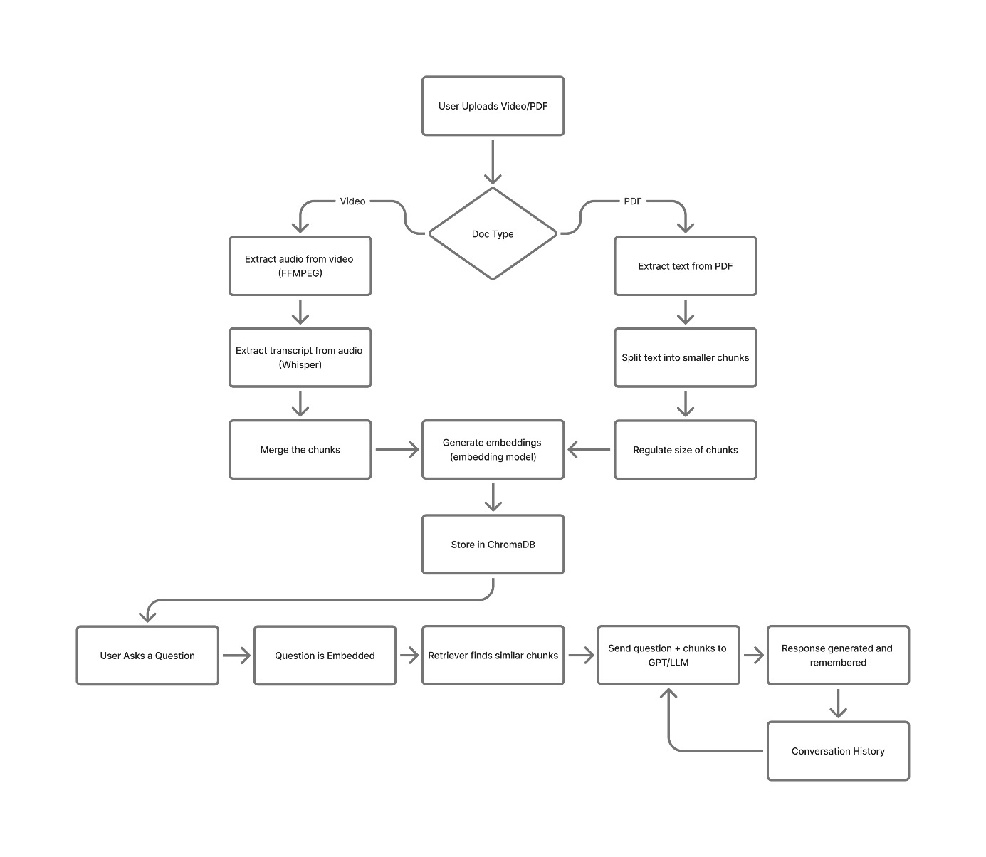
Figure 3.1 Workflow Diagram
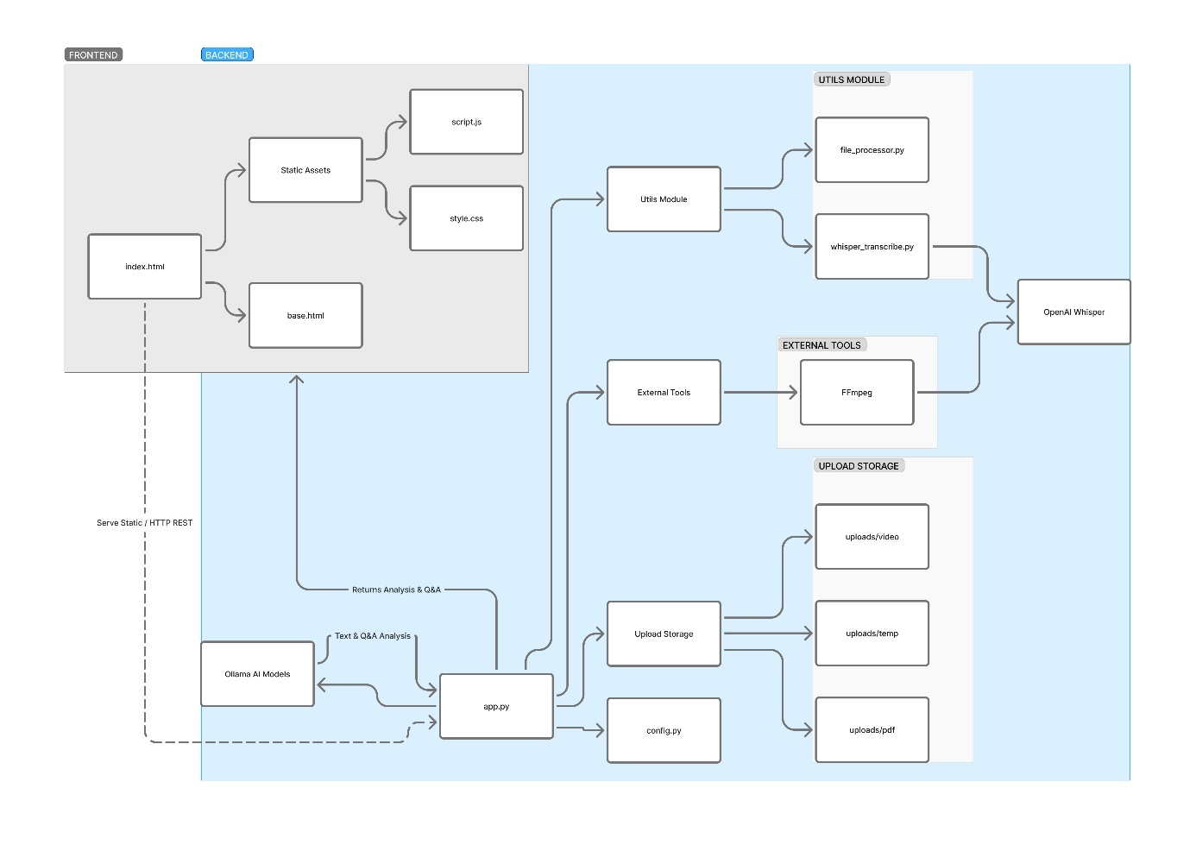
Figure 3.2 Code Architecture

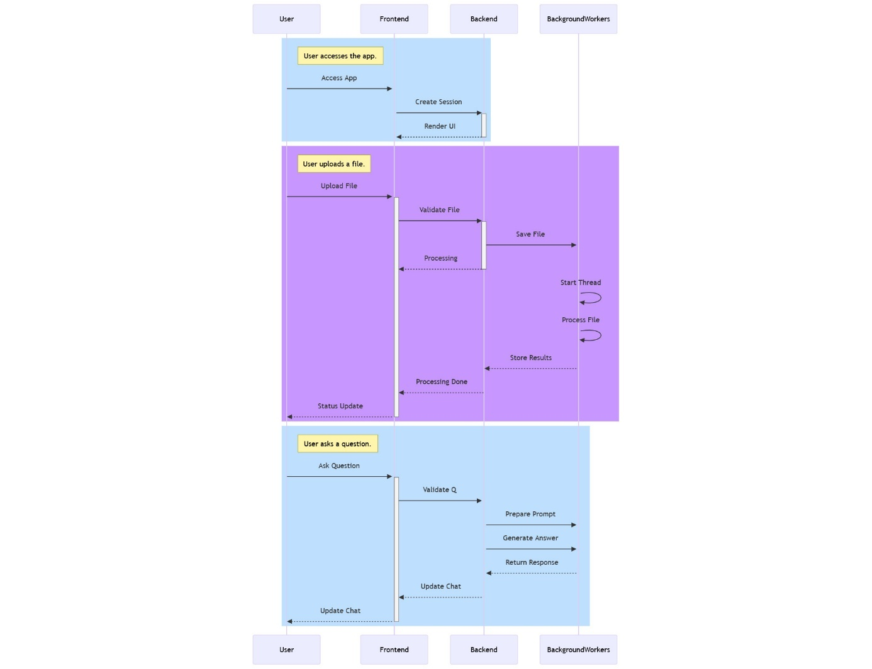
Figure 3.3 Activity Diagram

CHAPTER 4: IMPLEMENTATION OF PROJECT

The implementation phase of Swar AI focuses on converting our planned design into a working system. Each part of the pipeline was developed and tested step-by-step to make sure it works correctly and smoothly. We followed a modular approach—meaning we built each component separately and then connected them together.
4.1 Setting Up the Development Environment
Software and Tools Used:
- Programming Language: Python 3.10+
- Frontend: React (for user interface)
- Backend Framework: Flask (for API communication and local inference)
- Database: ChromaDB (for storing embeddings and retrieval)
- IDE: Visual Studio Code
- Version Control: Git and GitHub for version tracking and collaboration
Hardware Requirements:
- Minimum: 8 GB RAM, 4-core CPU
- Recommended: 16 GB RAM, GPU for faster model inference
- Storage: At least 5 GB for model files and user data
Python Libraries Installed:
- torch, transformers – for running local LLMs and embedding models
- chromadb – for storing and retrieving embeddings
- sentence-transformers or embeddingGemma – for semantic vector representation
- whisper – for speech-to-text from video/audio content
- moviepy, ffmpeg-python – for handling videos
- numpy, pandas – for basic data handling
- flask, flask-cors – for connecting backend with frontend
- langchain – for implementing RAG logic (retrieval + generation)

4.2 Backend Development
The backend was implemented using Python and Flask. It handles all the main processing, including file uploads, speech recognition, embedding generation, document retrieval, and chat responses.
The system follows a RAG (Retrieval-Augmented Generation) pipeline:

A. Data Upload and Processing
- Users can upload videos, PDFs, or images through the frontend.
- For videos, FFmpeg and Whisper are used to extract and transcribe spoken content.
- For PDFs and images, PyMuPDF or Tesseract OCR extracts readable text.
- The extracted text is then stored locally for embedding.

B. Embedding Generation
- Models like embeddingGemma or BERT are used to convert extracted text into numerical vector representations (embeddings).
- These embeddings capture the semantic meaning of the content.
- Embeddings are saved in ChromaDB, a local vector database for fast retrieval.

C. Retrieval Module
- When the user asks a question, the system searches ChromaDB for the most relevant documents or text chunks.
- The top results (based on similarity) are passed to the language model along with the user’s question.

D. Conversational Response Generation
- A local LLM such as Gemma or GPT-OSS generates a helpful and context-aware answer using retrieved information.
- Since the model runs fully offline, the data remains on the user’s machine.
- The generated response is sent back to the frontend chat panel.

E. Multimodal Integration
- For video and image queries, the system uses metadata and transcribed text to respond contextually.
- For example, users can ask, “Explain the topic discussed in this video section,” and the model retrieves that part from the transcription.

F. Flask API Integration
- Flask provides RESTful endpoints for:
  - Uploading files
  - Retrieving embeddings
  - Handling chat messages
  - Managing database operations

4.3 Frontend Development
The frontend was developed using React to provide a clean and interactive interface.
Key features include:
- File Upload Section: Allows uploading of videos, PDFs, and images.
- Side-Panel Chat Interface: Users can ask questions related to the uploaded content.
- Real-Time Context Display: Shows retrieved chunks and related text in the background.
- Dark/Light Mode and Responsive UI: Makes the platform user-friendly across devices.
4.4 Testing and Debugging
To make sure each part works well, we tested everything one by one:
- Unit Testing: Each function like audio extraction, transcription, and translation was tested with sample files.
- Integration Testing: We ran the full pipeline on 2–3 different videos to check end-to-end flow.
- Error Handling: If any step fails (e.g., model not loaded), the system shows a clear message.
- Speed Testing: We compared processing time with and without GPU. GPU made it 2x faster but CPU-only also works.

4.5 Database and Data Management
To keep the system organized and efficient, the following structure was followed:
Folder Structure:
- /uploads – Stores uploaded user files (videos, PDFs, images)
- /transcripts – Contains text generated by Whisper or OCR
- /embeddings – Stores embedding vectors and Chroma database files
- /responses – Saves chat logs and generated answers
- /logs – Stores backend logs for debugging

4.5 Screenshots:

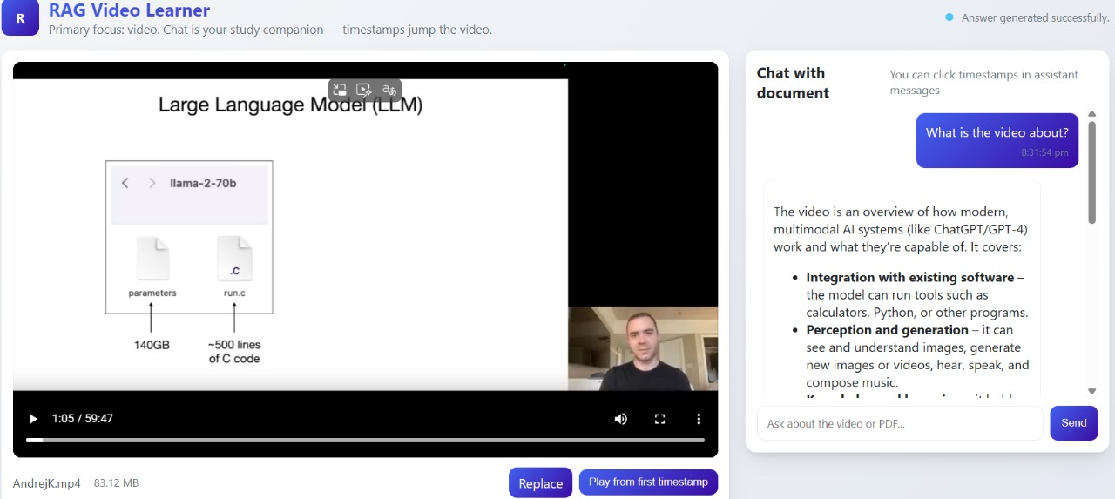
Figure 4.1 AI providing solution on Video inputs

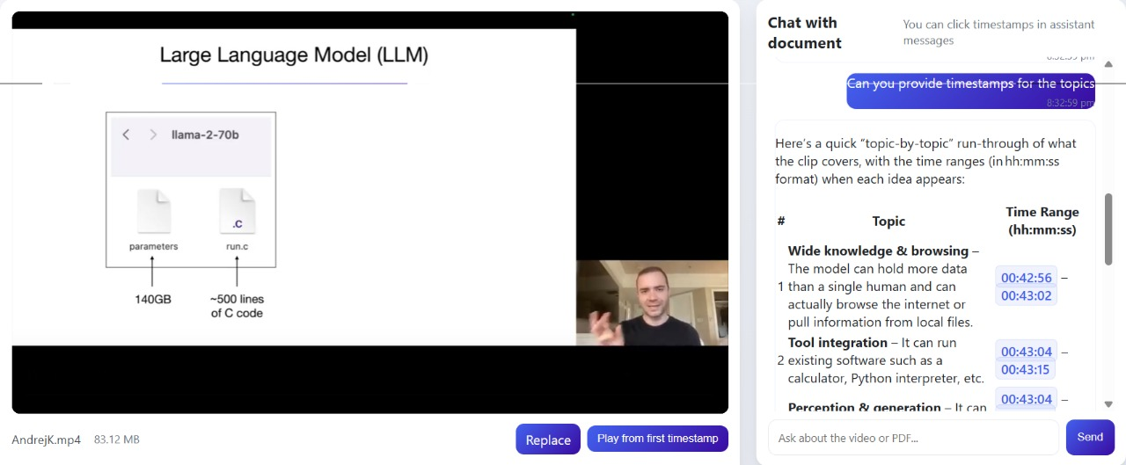
Figure 4.2 AI responding with timestamp

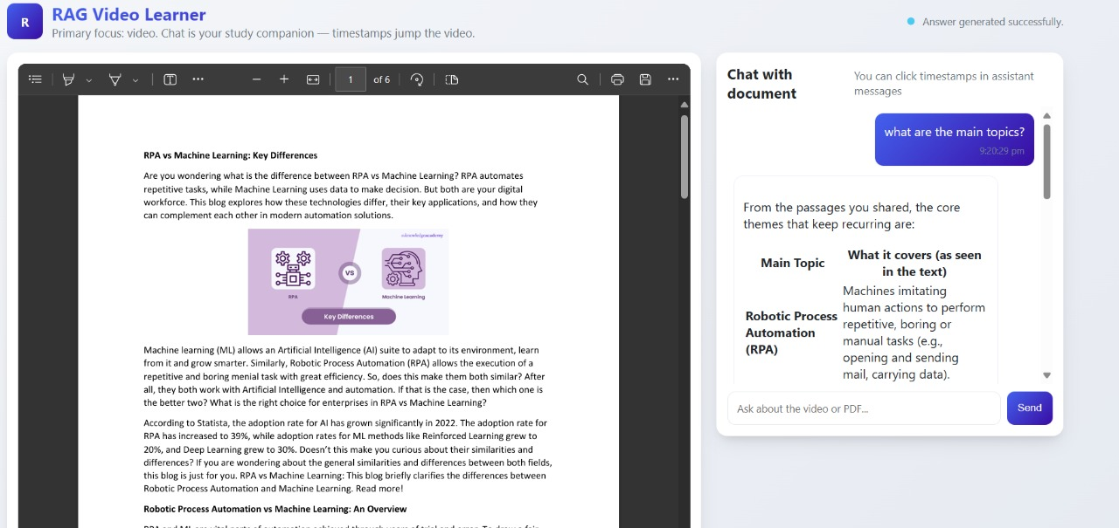
Figure 4.3 Q&A based on input documents

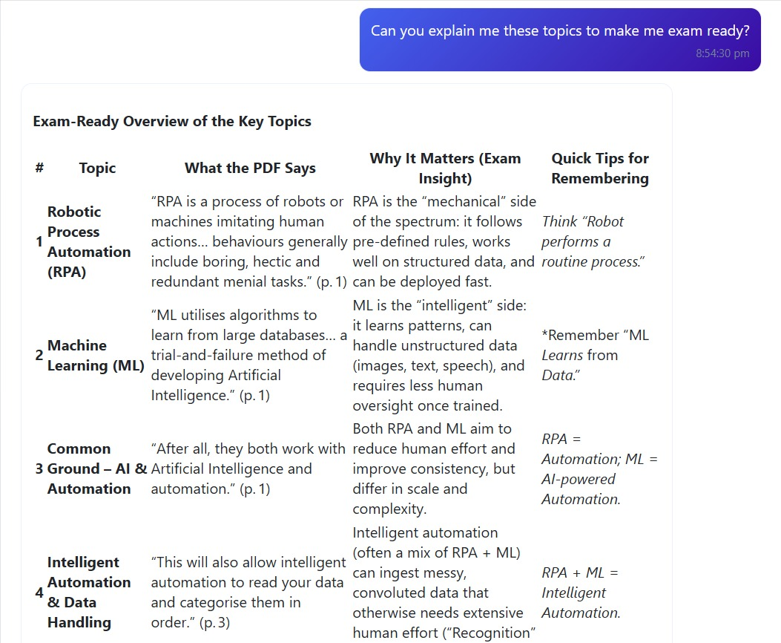
Figure 4.4 Q&A based on input document

CHAPTER 5: TESTING
5.1 Objective of Testing
Once the system was fully developed, it was tested with different types of input data — videos, PDFs, and images — to check its functionality.
1. Video Input Test:
- The user uploads an educational video.
- The system extracts the audio using FFmpeg and converts it into text using Whisper ASR.
- The transcription is stored locally, and the content becomes searchable.
- When the user asks a question related to the video (e.g., “What topic was discussed around 5 minutes?”), the system retrieves the relevant transcript section and provides a clear explanation through the chat interface.
2. PDF Input Test:
- A PDF containing lecture notes was uploaded.
- The system extracted text using PyMuPDF and stored embeddings in ChromaDB.
- When a user asked, “Summarize Chapter 2,” the system quickly retrieved the relevant parts and generated a summarized answer.
3. Image Input Test:
- An image of a diagram or handwritten note was uploaded.
- Using Tesseract OCR, the system extracted text and created embeddings.
- The user could then ask, “Explain this diagram,” and the model provided a detailed explanation.
The outputs showed that the system could handle all input formats smoothly and respond intelligently based on stored information.

5.2 Types of Testing Performed
The system was tested on a local machine with 8 GB RAM and 4-core CPU (no GPU). Despite being offline, it performed efficiently with acceptable response times.
Test Type | Input Size | Processing Time | Output Quality
Video (10 mins) | ~100 MB | 2.5 – 3 minutes | Accurate transcription and relevant answers
PDF (20 pages) | ~2 MB | 20 – 25 seconds | Correct retrieval and summarization
Image (text content) | ~1 MB | 10 – 15 seconds | Clear text extraction and explanation

5.3 Testing Results
Offline Functionality:
The entire system works without internet access. All files, models, and responses are processed locally, ensuring full privacy.
Multimodal Learning Support:
The platform can process multiple types of educational content — text, images, and videos — making it useful for different learning styles.
Efficient Information Retrieval:
With ChromaDB embeddings, the system quickly finds the most relevant pieces of information based on user queries.
Contextual Chat Assistance:
The chat interface provides meaningful, context-based answers by combining retrieval and generation (RAG) effectively.
User Privacy and Security:
Since no external API or cloud service is used, all data stays on the user’s device. This makes it ideal for students and institutions that prefer offline systems.

5.4 Limitations Observed
While the platform performed well, some limitations were observed during testing:
- The initial model loading time was slightly long due to large file sizes (especially for Gemma and Whisper).
- The system requires moderate hardware resources for smooth operation; low-end devices may experience slower responses.
- For very large files (e.g., long videos or high-resolution PDFs), preprocessing time increases.
- The user interface is basic in this version; future updates can include better design and advanced features like drag-and-drop uploads or voice queries.

CHAPTER 6: LIMITATION & FUTURE ENHANCEMENT

6.1 Limitations
- Limited Scalability
Currently, the system works best for personal use or small-scale usage. If multiple users try to access the platform simultaneously or if very large videos or PDFs are uploaded together, the system may slow down or become unresponsive. To handle larger workloads, the backend architecture and hardware support need to be enhanced.
- Offline Only, No Cloud Support
The platform is fully offline to ensure privacy, but this also means there is no cloud storage, collaboration, or backup. Users must rely on their local machine’s storage and processing power, which can be limiting for large datasets or multiple users.
- Basic User Interface
The current interface is simple — a basic React chat panel or CLI-based system. Features like drag-and-drop uploads, real-time progress indicators, and material previews are missing, making the experience less interactive for beginners.
- Limited Language Support
At present, the system supports processing mainly in English and one or two target languages (like Hindi or Gujarati). Additional Indian or regional languages are not yet supported, limiting accessibility for a wider audience.
- No Emotion-Aware Responses
While the platform can generate context-aware answers, it cannot adjust tone, style, or emotion based on user preference. Responses are purely factual and neutral, which may feel less engaging for some learners.
- No Real-Time Interaction
Processing is sequential: uploading, embedding, retrieval, and response generation happen step-by-step. There is currently no real-time partial preview or immediate feedback while content is being processed.
.

6.2 Future Enhancements
- Cloud Integration
In the future, the platform can be deployed on cloud servers such as AWS, Google Cloud, or Azure, allowing online uploads, faster GPU-based processing, and cloud storage for easy access across devices.
- Improved Frontend Interface
We plan to develop a modern, interactive web interface using React or Next.js, featuring drag-and-drop uploads, progress bars, previews, and real-time chat with AI assistance.
- Support for More Languages
Future versions will integrate additional Indian languages such as Tamil, Telugu, Bengali, Marathi, and others, making the platform accessible to a larger and more diverse audience.
- Emotion-Aware Responses
Adding emotion control in the responses will allow the AI to provide explanations or feedback in different tones, such as enthusiastic, calm, or encouraging, improving user engagement.
- Mobile Application
A mobile version using React Native or Flutter will allow users to upload, process, and interact with study materials directly from their smartphones.
- Real-Time Retrieval & Response
Future enhancements will aim for near real-time processing, where users can see partial responses, summaries, or extracted information as soon as materials are uploaded.
- Analytics and Progress Tracking
Adding dashboards to show statistics like the number of queries answered, most studied topics, time saved, and learning progress can provide insights to learners and educators.
- Integration with External Platforms
Direct integration with platforms like Google Drive, YouTube, or Dropbox will simplify uploading, sharing, and accessing study materials.

CHAPTER 7: CONCLUSION
The Local RAG-based Educational Platform is an intelligent and user-friendly system designed to help learners study and interact with educational content such as videos, PDFs, and images. By combining local embeddings (embeddingGemma/BERT), ChromaDB (for vector storage), Whisper (for speech transcription), and a local language model (Gemma or GPT-OSS), the platform provides contextual and interactive assistance without relying on the internet. All modules work together in a smooth, fully offline pipeline.
This project addresses a key challenge in self-learning: accessing and understanding educational resources effectively. Many learners struggle to quickly find answers or understand the content in videos, documents, or images. Traditional methods, like reading entire PDFs or rewatching videos, are time-consuming and inefficient. The RAG-based system solves this by retrieving the most relevant content and generating concise, context-aware answers, making learning faster and more efficient.
The platform also ensures data privacy and security, since all processing happens locally. Learners can upload their study materials with confidence, and the system works entirely offline, making it useful in areas with limited or no internet connectivity. Furthermore, the multimodal capability allows users to interact with different types of content in one place, enhancing understanding and retention.
While the current system performs well, there are opportunities for future improvements, such as supporting more languages, improving the user interface, enabling real-time responses, and integrating analytics. Even in its current state, the platform demonstrates the potential of AI to support interactive self-study, enhance learning efficiency, and make educational resources more accessible.
In conclusion, this project shows that a fully local, RAG-based educational system can be an effective, private, and versatile tool for learners. It makes studying interactive, personalized, and efficient, paving the way for intelligent self-learning solutions that can work anywhere, anytime, and across diverse types of educational content.

CHAPTER 8: REFERENCES
- OpenAI – Whisper Speech Recognition
- Google – Gemma: Open Models by Google DeepMind
- Hugging Face – Transformers Library
- Python Official Documentation
- PyTorch – Deep Learning Framework
- NumPy – Scientific Computing Library
- FFMPEG – Multimedia Framework for Audio/Video Processing
- Papers with Code – AI Research Papers and Benchmarks
- GitHub

